P.VENKATA KISHORE
192412581
14: 5G Throughput vs SNR with Modulation Labels

Objective 1: To evaluate the Throughput (Mbps) of a 5G communication system under different Signal-to-Noise Ratio (SNR) conditions.

Matlab Code:
clc;
clear;
close all;
% SNR values (dB)
SNR = 0:5:30;
% Maximum Throughput (Mbps)
Max_TP = 100;
% Throughput calculation
Throughput = Max_TP*(1-exp(-SNR/10));
disp('SNR(dB) Throughput(Mbps)')
disp([SNR' Throughput'])
figure
% -------- Graph 1 --------
subplot(2,1,1)
plot(SNR,Throughput,'-o','LineWidth',2)
title('5G Throughput vs SNR')
xlabel('Signal-to-Noise Ratio (dB)')
ylabel('Throughput (Mbps)')
grid on
% -------- Graph 2 --------
subplot(2,1,2)
bar(Throughput)
title('Throughput at Different SNR Levels')
xlabel('SNR Index')
ylabel('Throughput (Mbps)')
grid on
Output:
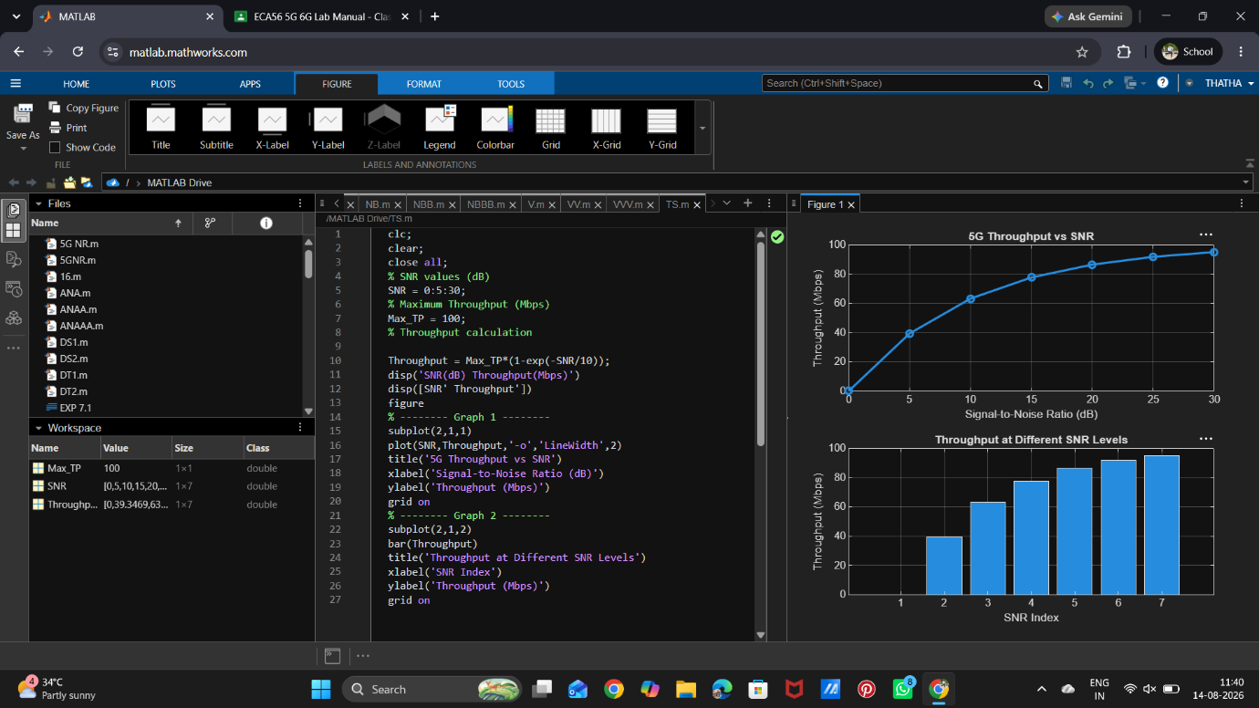

Objective 2: To analyze the effect of Signal-to-Noise Ratio (SNR) (dB) on the performance and reliability of the 5G communication system.

Matlab Code:
clc;
clear;
close all;
% SNR values (dB)
SNR = 0:5:30;
% Simulated Bit Error Rate (BER)
BER = [0.30 0.18 0.10 0.05 0.02 0.008 0.001];
% Reliability (%)
Reliability = (1-BER)*100;
disp('SNR(dB) BER Reliability(%)')
disp([SNR' BER' Reliability'])
figure
% -------- Graph 1 --------
subplot(2,1,1)
semilogy(SNR,BER,'-o','LineWidth',2)
title('SNR vs Bit Error Rate in 5G')
xlabel('Signal-to-Noise Ratio (dB)')
ylabel('Bit Error Rate (BER)')
grid on
% -------- Graph 2 --------
subplot(2,1,2)
plot(SNR,Reliability,'-s','LineWidth',2)
title('SNR vs Communication Reliability')
xlabel('Signal-to-Noise Ratio (dB)')
ylabel('Reliability (%)')
grid on
Output:
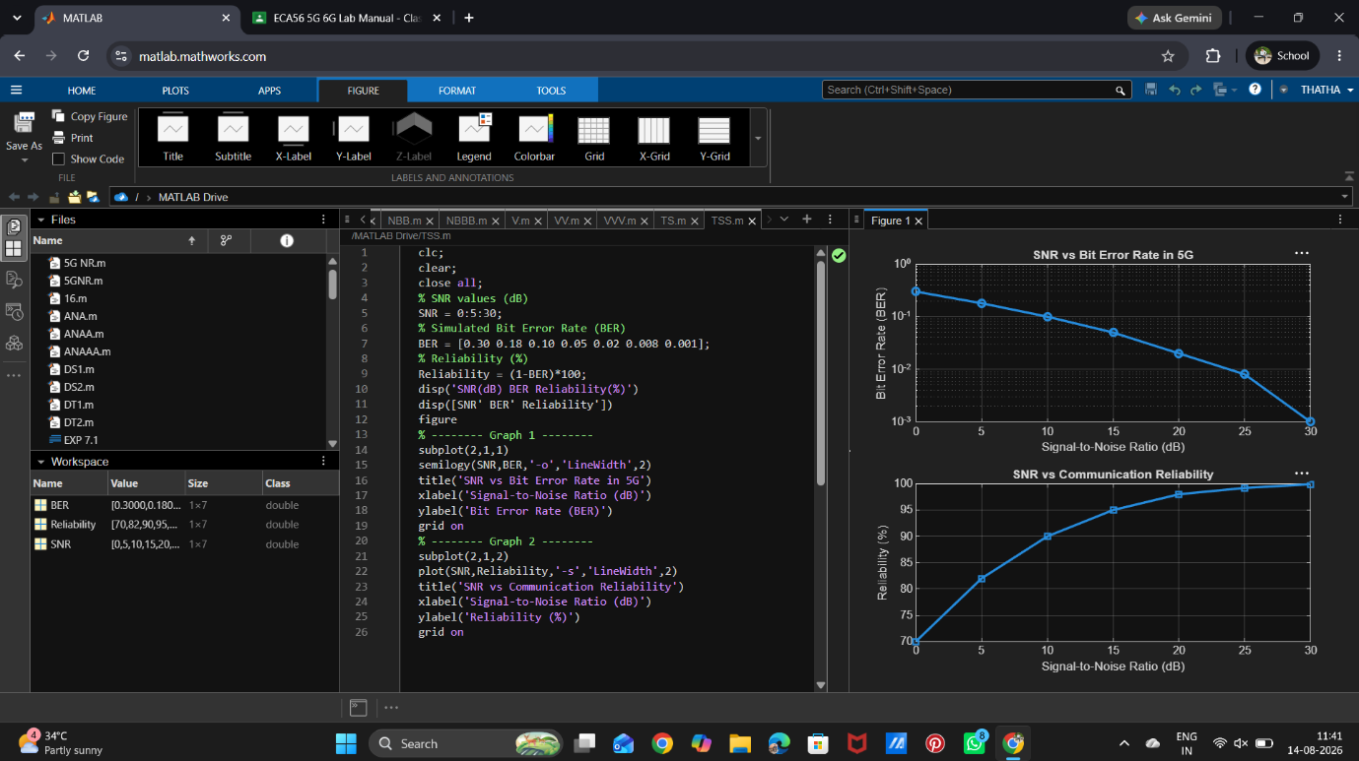

Objective 3: To compare the performance of different Modulation Schemes (QPSK, 16-QAM, 64-QAM, and 256-QAM) and determine their suitability for varying SNR conditions.

Matlab Code:
clc;
clear;
close all;
% Modulation schemes
Modulation = {'QPSK','16-QAM','64-QAM','256-QAM'};
% Required SNR (dB)
SNR = [5 10 18 25];
% Spectral Efficiency (bits/s/Hz)
Efficiency = [2 4 6 8];
disp('Required SNR (dB) and Spectral Efficiency')
disp(table(Modulation',SNR',Efficiency', ...
'VariableNames',{'Modulation','SNR_dB','Efficiency'}))
figure
% -------- Graph 1 --------
subplot(2,1,2)

plot(SNR,Efficiency,'-o','LineWidth',2)
title('SNR vs Spectral Efficiency')
xlabel('Signal-to-Noise Ratio (dB)')
ylabel('Spectral Efficiency (bits/s/Hz)')
grid on
% -------- Graph 2 --------
subplot(2,1,1)
plot(1:4,SNR,'-s','LineWidth',2)
xticks(1:4)
xticklabels(Modulation)
title('Required SNR for Different Modulation Schemes')
xlabel('Modulation Scheme')
ylabel('Required SNR (dB)')
grid on

Output:
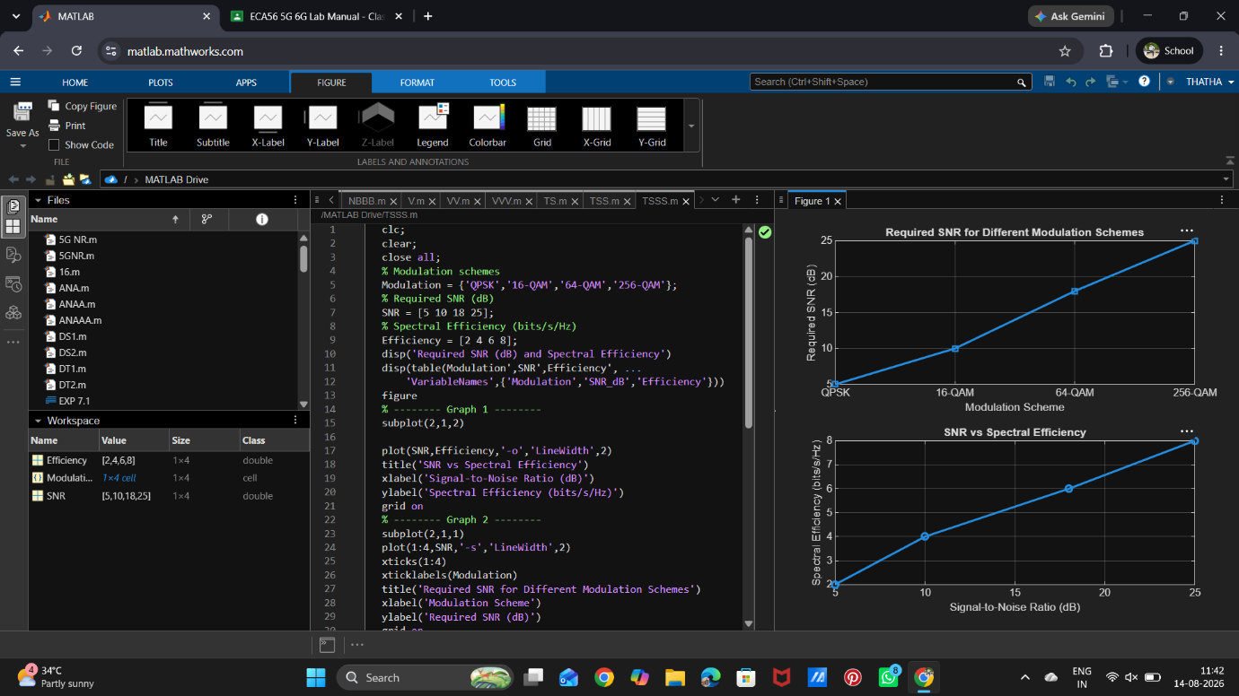

Result: The Throughput (Mbps) of the 5G communication system increased with increasing Signal-to-Noise Ratio (SNR), demonstrating improved data transmission performance.

